Nam Nguyen

npn190000

1.

Consider 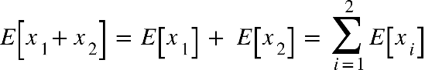

The error using the aggregated model is defined as:

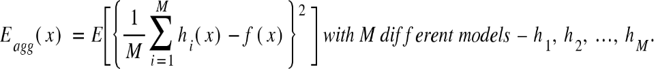

Prove: 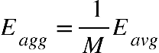

E subscript a g g end subscript open parentheses x close parentheses space equals space E open square brackets open curly brackets 1 over M sum from i equals 1 to M of h subscript i open parentheses x close parentheses minus f open parentheses x close parentheses close curly brackets squared space close square brackets space
space space space space space space space space space space space space space space space equals space E open square brackets 1 over M squared open square brackets sum from i equals 1 to M of h subscript i open parentheses x close parentheses minus f open parentheses x close parentheses close square brackets squared space close square brackets space
space space space space space space space space space space space space space space space equals space 1 over M squared. E open square brackets sum from i equals 1 to M of h subscript i open parentheses x close parentheses minus f open parentheses x close parentheses close square brackets squared space space
space space space space space space space space space space space space space space space equals space 1 over M squared. E open square brackets sum from i equals 1 to M of minus open parentheses f open parentheses x close parentheses minus h subscript i open parentheses x close parentheses close parentheses close square brackets squared space space

The error for each of the models would be described as:

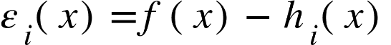

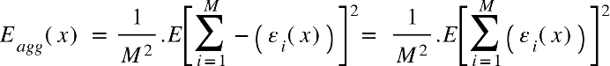

The average value of the expected squared error for each of the models acting individually is defined as:

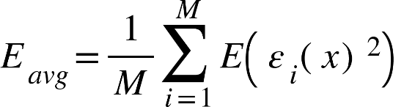

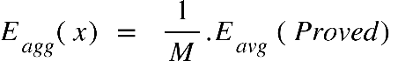

2.

In question 1, we had assumed that each of the errors are uncorrelated i.e. 𝐸 left parenthesis epsilon subscript i space left parenthesis 𝑥 right parenthesis epsilon subscript j left parenthesis 𝑥 right parenthesis right parenthesis space equals space 0 space f o r space a l l space i space not equal to space j

This is not really true, as the models are created using bootstrap samples and have correlation with each other. Now, let's remove that assumption. Show that using Jensen's inequality, it is still possible to prove that: E subscript a g g space end subscript less or equal than E subscript a v g end subscript

Jensen's inequality states that for any convex function f

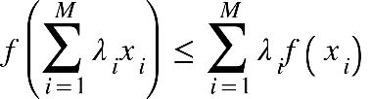

E open square brackets x close square brackets space equals space sum from i equals 1 to M of lambda subscript i x subscript i space semicolon space space space E open square brackets f open parentheses x close parentheses close square brackets equals sum from i equals 1 to M of lambda subscript i f open parentheses x subscript i close parentheses


We have simple case: E open square brackets f open parentheses x close parentheses close square brackets equals lambda subscript 1 space space end subscript f open parentheses x subscript 1 close parentheses space plus lambda subscript 2 space space end subscript f open parentheses x subscript 2 close parentheses space greater or equal than f open parentheses lambda subscript 1 space space end subscript x subscript 1 space plus lambda subscript 2 space space end subscript x subscript 2 close parentheses equals space f open parentheses E open square brackets x close square brackets space close parentheses


Consider:

E open square brackets f open parentheses x close parentheses close square brackets equals sum from i equals 1 to M of lambda subscript i f open parentheses x subscript i close parentheses equals space open parentheses lambda subscript 1 space plus space lambda subscript 2 close parentheses open parentheses fraction numerator lambda subscript 1 space space end subscript f open parentheses x subscript 1 close parentheses space plus lambda subscript 2 space space end subscript f open parentheses x subscript 2 close parentheses space over denominator lambda subscript 1 space plus space lambda subscript 2 end fraction close parentheses plus space lambda subscript 3 space space end subscript f open parentheses x subscript 3 close parentheses plus... space plus lambda subscript M space space end subscript f open parentheses x subscript M close parentheses space


greater or equal than space open parentheses lambda subscript 1 space plus space lambda subscript 2 close parentheses times f open parentheses fraction numerator lambda subscript 1 space space end subscript x subscript 1 space plus lambda subscript 2 space space end subscript x subscript 2 space over denominator lambda subscript 1 space plus space lambda subscript 2 end fraction close parentheses plus space lambda subscript 3 space space end subscript f open parentheses x subscript 3 close parentheses plus... space plus lambda subscript M space space end subscript f open parentheses x subscript M close parentheses space


greater or equal than space f open parentheses open parentheses lambda subscript 1 space plus space lambda subscript 2 close parentheses times open parentheses fraction numerator lambda subscript 1 space space end subscript x subscript 1 space plus lambda subscript 2 space space end subscript x subscript 2 space over denominator lambda subscript 1 space plus space lambda subscript 2 end fraction close parentheses plus space lambda subscript 3 space space end subscript x subscript 3 plus... space plus lambda subscript M space space end subscript x subscript M space close parentheses


equals space f open parentheses lambda subscript 1 space space end subscript x subscript 1 space plus lambda subscript 2 space space end subscript x subscript 2 plus space lambda subscript 3 space space end subscript x subscript 3 plus... space plus lambda subscript M space space end subscript x subscript M space close parentheses equals space f open parentheses E open square brackets x close square brackets space close parentheses


Hence: E[f(x)] ≥ f(E[x])

E subscript a g g space end subscript less or equal than E subscript a v g end subscript

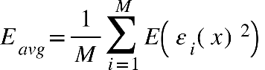

E subscript a g g end subscript open parentheses x close parentheses space equals space E open square brackets open curly brackets 1 over M sum from i equals 1 to M of h subscript i open parentheses x close parentheses minus f open parentheses x close parentheses close curly brackets squared space close square brackets space
space space space space space space space space space space space space space space space equals space E open square brackets 1 over M squared open square brackets sum from i equals 1 to M of h subscript i open parentheses x close parentheses minus f open parentheses x close parentheses close square brackets squared space close square brackets space
space space space space space space space space space space space space space space space equals space 1 over M squared. E open square brackets sum from i equals 1 to M of h subscript i open parentheses x close parentheses minus f open parentheses x close parentheses close square brackets squared space space
space space space space space space space space space space space space space space space equals space 1 over M squared. E open square brackets sum from i equals 1 to M of minus open parentheses f open parentheses x close parentheses minus h subscript i open parentheses x close parentheses close parentheses close square brackets squared space space

(Proved)

3.